CATME
Comprehensive Assessment of Team Member Effectiveness

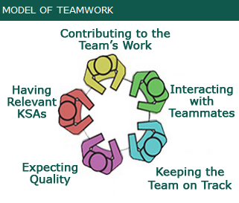

CATME offers a suite of tools found on their website (http://info.catme.org/) along with video tutorials and research articles. The Peer Evaluation tool is offered in both web-based and Microsoft Word formats:

“CATME Peer Evaluation has a number of features that make it convenient and appropriate. Students rate themselves and their teammates using a secure, web-based interface. This provides confidentiality, especially compared to paper and pencil evaluations completed during class. However, the system allows instructors to view each student’s ratings of every team member, which increases students’ accountability for their ratings. Students can also make confidential comments in the system, which go only to their instructor. The system flags a number of “exceptional conditions” in the rating patterns to alert instructors to teams or students who might benefit from their attention. The system also allows instructors to release feedback to their students. The feedback shows students their self-rating, the average rating that teammates gave the student, and the team-average rating for each of the five dimensions of the CATME Peer Evaluation scale. In addition, the feedback suggests behaviors that could improve students’ ratings in each of the five dimensions. Instructors can also choose to release messages alerting students to any exceptional conditions in their rating patterns.

A Word document containing CATME’s Peer Evaluation instruments is available for instructional and research use. The Behaviorally Anchored Rating Scale version of the instrument is the one used in our online administration. The Word document also includes the Likert-scale version of the instrument in the short and long formats.”

CATME provides documents/templates such as team charter, meeting agenda, meeting minutes, etc. that can be used by student teams. (http://info.catme.org/meeting-support/)

