Navigating Conflict
Activity Guide Book

Created by:
Genevieve Derban, Megan Kendall, and Thomas O’Neill

OVERVIEW
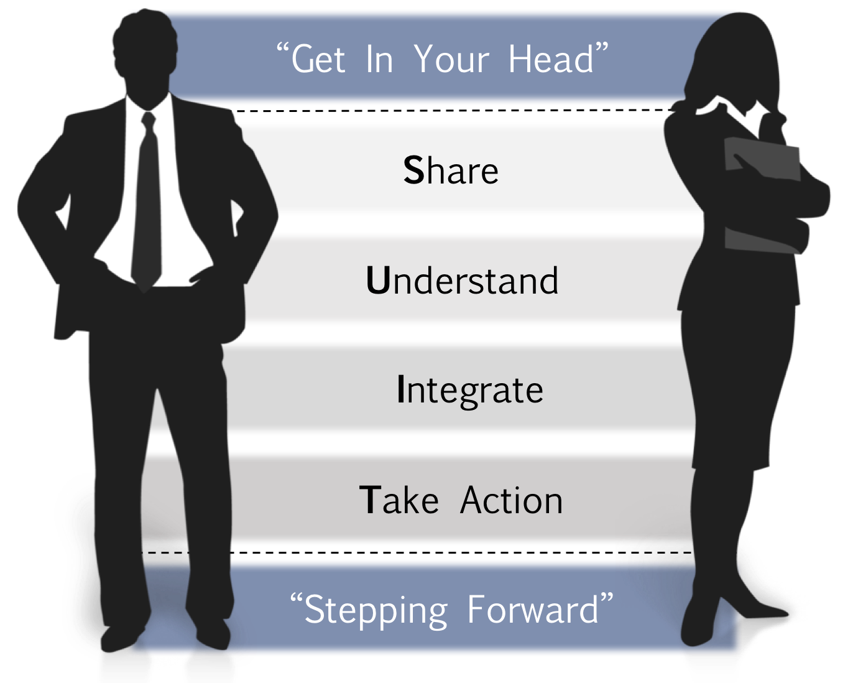
GET IN YOUR HEAD. The objective is to prepare for a successful conversation by analyzing your intentions and actions. Start With Heart and Retrace Your Path help you set the stage.
Skills: Self Awareness & Reflection.

SHARE. The objective is to share your path and listen to the other side of the conflict. Do not think about your own response; rather, listen for the purposes of understanding and empathy.
Skills: Non-verbal Empathetic Listening & Mirror/Paraphrasing Content & Emotion.

UNDERSTAND. The objective is to build a complete understanding of the conflict and clarify any potential misunderstandings about each other’s perspective. In understanding the problem, potential solutions should start to emerge and be noted for the next step.
Skills: Asking Open-Ended, Clarifying Questions & Verbal Empathetic Listening.

INTEGRATE. The objective is to integrate generated solutions. Spend time generating various ideas for solutions that could be integrated to create a win-win solution that both parties can agree on. Identify barriers and solutions to those barriers that could satisfy both parties.
Skills: Solution Integration & Perspective Taking.

TAKE ACTION. The objective is to set up an action plan that both parties agree to and are committed to implementing. Identify who is accountable for next steps.
Skills: Accountability/Commitment & Goal Setting.

STEPPING FORWARD. The objective is to move forward in your action plan. Let go of negative emotions. Follow-up on the conflict and your role in the resolution.
Skills: Letting Go & Follow-Up.
SAFE CONTEXT
Surrounding our model is the safe context. It is important to remember the distinction between content and context. Always be sure to set up a safe context for a conflict resolution to occur and continually ensure that the context remains safe throughout every step.

SUIT Steps for Conflict Resolution

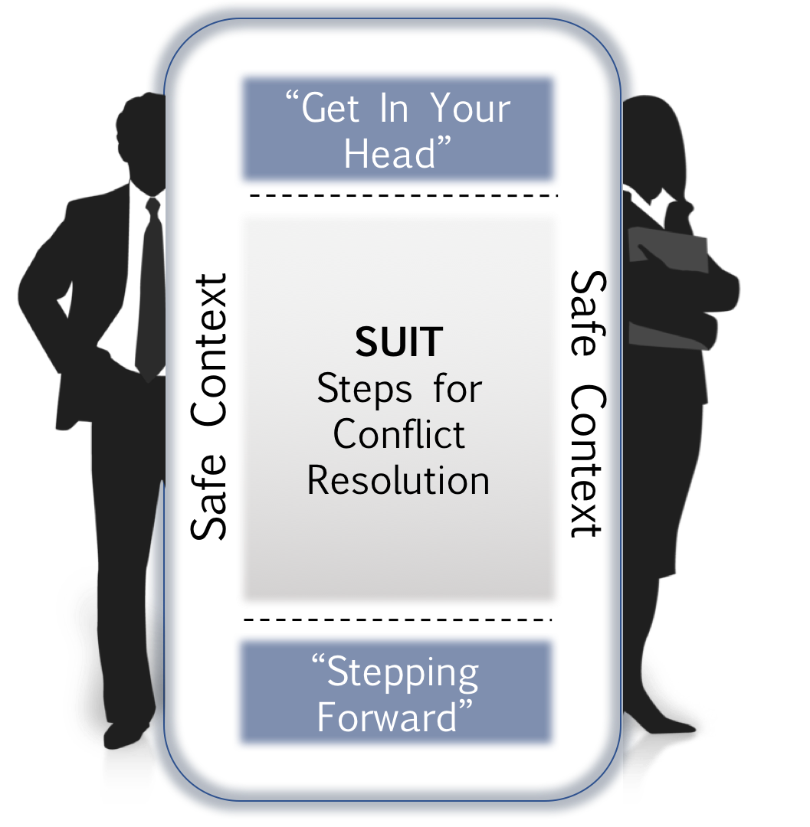

PACE Strategies for a Safe Context

1. Create a mutual Purpose
Create a mutual purpose. Try and create a higher or longer-term purpose | We want to have a healthy working relationship…  We want to perform at the highest level possible…  We want to ensure our customers get the best…
2. Apologize when appropriate
Statement that sincerely expresses your sorrow for your role in causing/not preventing pain for others  Never use the term “but” here! | I’m genuinely sorry you’re feeling [X], I honestly never meant to hurt anyone’s feelings.  I want to apologize for my role in creating this situation and any harm I may have caused.
3. Contrast to fix misunderstanding
Use a statement that contrasts what you perceive they are feeling with what you truly mean. | The last thing I wanted was to make you feel under-valued [don’t part]. I think you are an extremely valuable member of this team [do part].”
4. Empathetic listening
Seeking to understand, to truly understand…  Use open body language, do not think about your next comment  Use AMP to show empathetic listening | Ask open-ended questions:  I want to hear your opinion/thoughts/perspective...  What have you observed that led to this issue?  Tell me more about…; How is this affecting you?  Mirror Content and Emotion to confirm  So you’re feeling…  So you are thinking that…  So you were doing/focused on/helping…  Paraphrase the Story  Let’s see if I have this right, you’re concerned/upset/suspicious because…
Remember your Non-Verbals!
Lean in, eye contact, nodding, “uh-huh” and “mm-hmm”, smiling when appropriate, open arms, friendly tone, volume, and intensity, friendly expression, face the person, etc.
STATEMENT OF THE CONFLICT
Stating the basics of the conflict helps to clear your thinking of the conflict and lays the groundwork for reflecting on your role in it. It may be helpful to ask yourself at this stage, is there a true conflict here? And is the other person aware of it?
The conflict I want to resolve involves:
Who is involved:

When did the conflict begin:

Where does the conflict take place:

What is happening that creates the conflict:

Know Yourself: Conflict Management Style Review
My preferred conflict style is ___________________________________________________________
In this conflict my preferred style will impact my actions by….

START WITH HEART
Before a conflict conversation it is important to check in with yourself to ensure your intentions and motivations are clear for the conversation.
Begin thinking about the following:  - What do I want for myself?  - What do I want for others?  - What do I want for the relationship?  - Am I ready and willing to solve the issue? | The goal of this stage is to clarify your motivations and intentions for resolving this conflict.  You know you have reached this goal when you are clear about what you want, and why you want it, for yourself, others, and the relationship.

To help achieve this goal, finish these statements and use the following as work space.
For me, it is important that I can/have/do/feel…

What I want for you is…

What I want for our relationship is…

What I want for our team/organization is…

Now is the best time to resolve this conflict because…

RETRACE YOUR PATH
In the conflict conversation, you will share your perceived role (path) in the conflict.
Prepare for this by critically thinking about the following:  - Notice your behavior (e.g., am I in silence or violence)?  - What emotions are related to my actions?  - Am I basing my story on factual evidence?  - How strong is my evidence, am I making assumptions? | The goal of this stage is to objectively analyze your role and emotional reactions in this conflict.  You know you have reached this goal when you are able to articulate your path through this conflict using your actions and emotions as guides. Be prepared to share this path with the other party.
To help achieve this goal, finish these statements and use the following as workspace.
My behaviors with respect to this issue involve…

My emotions related to this issue are…

The specific facts driving my story are…

The assumptions influencing my story are…

SHARE
Refer to the notes you made on the Start with Heart and Retrace your Path activities.
In partners, share the background to the conflict you brought to the session (i.e., who, what, when, where, etc.). Then state your “path” to your partner as if they are the person you are experiencing conflict with.
While your partner shares their path, you should display empathetic listening through non-verbal signals as well as practice mirroring and paraphrasing content and emotion effectively to establish safety and show listening.
The objective of this exercise will be to practice your listening skills and communicating your perspective of the conflict.

UNDERSTAND
Ask two open-ended*, clarifying questions that will help you potentially better understand any part of the situation or personal feelings that may be vague. This will help your partner in clarifying his or her path more effectively as well as help your practice asking clarifying questions.
*Open-ended questions require a response that expands beyond a single word (e.g., yes, no, etc.).
The objective of this exercise is to practice asking clarifying questions and to provide your partner with feedback on aspects of their path that could be clarified.
Test Yourself: Take Home Skill Builder
Practice asking open-ended, clarifying questions with this exercise after the workshop! Consider the following statements and imagine that you can only ask two open-ended, clarifying questions to better understand the conflict situation.
- “He just makes me so angry!”  - “I can’t work like this anymore!”  - “She broke my trust, and I don’t think our relationship will ever be the same.”  - “He just doesn’t understand my perspective.”  - “I hate her communication style.”  - “No one listens to me!” | - “He talks to me like I’m a child.”  - “She just keeps missing my point.”  - “She’s so aggressive!”  - “I don’t feel appreciated here.”  - “I’ve tried everything and nothing is getting through to him.”  - “She only focuses on what I do wrong.”

INTEGRATE
With your partner, take turns going through the potential roots of the problem. The problem root could be a different perception of:
- Goals – trying to achieve different things
- Roles – who should or can do what
- Procedures – methods/tactics to do something
- Relationships – how people relate to each other
- Limits – what is possible or level of power
- Timing – when something will be achieved
- Information – facts, figures or data being used
- Values – what’s right/wrong, ethical or fair
- Other – something else entirely

Decide with your partner on THREE potential problem roots that both you and your partner feel could be the root of the problem. Write these potential problem roots below. Try to relate each to a particular category above (e.g., Roles).
- ______________________________________________________________
- ______________________________________________________________
- ______________________________________________________________

Come up with THREE “If-Then” solutions that could potentially meet the needs of both parties. You should use perspective-taking to consider conflicting goals or needs of the other party and to generate meaningful solutions that could support both parties in the conflict, not just the individual sharing the conflict scenario.
For example, IF the root cause is a problem of “Roles”, where there is a lack of role clarity on who should do what, THEN a possible solution to the conflict could be discussing the roles in detail and defining tasks and areas of responsibility.
- _________________________________________________________________________________________________
_________________________________________________________________________________________________
- _________________________________________________________________________________________________
_________________________________________________________________________________________________
- _________________________________________________________________________________________________
_________________________________________________________________________________________________

The objective of this exercise is to practice taking perspectives of others and considering how to integrate potential solutions that meet the needs of both parties.
TAKE ACTION
With your partner, set a goal for how and when you will approach resolving your current conflict. Use the following SMART goal framework. (i.e., Specific, Measureable, Achievable, Realistic, Timely) to set your goal.

Leadership Challenge: Resolve a Conflict!
S | Specific  State exactly what you want to accomplish and why it is important to you/others.
M | Measurable  How will you demonstrate and evaluate the extent to which the goal has been met (i.e., what does success look like)?
A | Attainable  Explain how the goal is challenging but within your personal ability to achieve the outcome.
R | Relevant  How does the goal tie into your key responsibilities and align to the team’s objectives?
T | Timely  Set 1+ target dates that will guide your goal (specify deadlines and who you will follow up with and to whom you will be accountable).

The objective of this exercise is to resolve a conflict.

STEPPING FORWARD
It is important that you follow through on your goal setting and continue to hold yourself accountable for the actions you planned to take. It is equally important to not dwell on the past and to let go of things that cannot be changed. Maintain a future-focused mindset that allows you to continue move forward. Keep you workshop partner updated through regular (e.g., monthly, quarterly) coffee meetings.

