Steps for Navigating Conflict

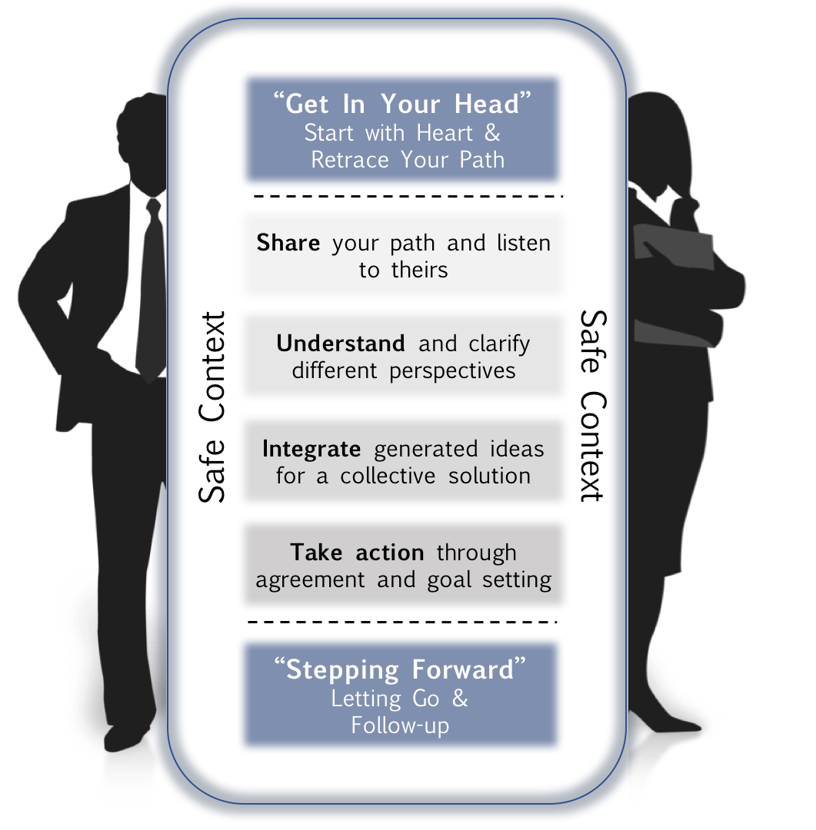
Safe Context
A safe context surrounds the model at every step. It is important to remember the distinction between content and context. Always set up a safe context for conflict resolution to occur and continually ensure that the context remains safe throughout every step.
PACE Strategies for a Safe Context

1. Create a mutual Purpose
Create a mutual purpose. Try and create a higher or longer-term purpose | We want to have a healthy working relationship…  We want to perform at the highest level possible…  We want to ensure our customers get the best…
2. Apologize when appropriate
Statement that sincerely expresses your sorrow for your role in causing/not preventing pain for others  Never use the term “but” here! | I’m genuinely sorry you’re feeling [X], I honestly never meant to hurt anyone’s feelings.  I want to apologize for my role in creating this situation and any harm I may have caused.
3. Contrast to fix misunderstanding
Use a statement that contrasts what you perceive they are feeling with what you truly mean. | The last thing I wanted was to make you feel under-valued [don’t part]. I think you are an extremely valuable member of this team [do part].”
4. Empathetic listening
Seeking to understand, to truly understand…  Use open body language, do not think about your next comment  Use AMP to show empathetic listening | Ask open-ended questions:  I want to hear your opinion/thoughts/perspective...  What have you observed that led to this issue?  Tell me more about…; How is this affecting you?  Mirror Content and Emotion to confirm  So you’re feeling…  So you are thinking that…  So you were doing/focused on/helping…  Paraphrase the Story  Let’s see if I have this right, you’re concerned/upset/suspicious because…
Remember your Non-Verbals!
Lean in, eye contact, nodding, “uh-huh” and “mm-hmm”, smiling when appropriate, open arms, friendly tone, volume, and intensity, friendly expression, face the person, etc.

