STRATEGIC VOLUNTEERISM: INSPIRING CHANGEMAKERS
express search workbook
A Companion to Strategic Volunteerism: Inspiring Changemakers Moodle Course

MARCH 2024

This Express Search Workbook is provided to support your use of the Strategic Volunteerism: Inspiring Changemakers Moodle Course. You can print this out, or fill in digitally as you work through the different activities. Over time, this will emerge as your own personal portfolio of your Strategic Volunteerism journey and will also help you with your ongoing career management activities.

Navigation tips:
- To go to a page or a heading in this document without scrolling you can use the active links in the index below.
Or
- Use the built in Word Navigation pane. To open the Navigation pane, press Ctrl+F, or select the View tab and under the “Show” options, choose “Navigation Pane”.

Workbook Index
🟠Find Your Spark
☐ Activity: Reflective Question Exercise

🟡Assemble Your Skills
☐ Activity: Uncover Your Personal Assets

🟣Develop Your Strategy
☐ Activity: Specify Your Parameters

🟢Plan Your Action
☐ Activity: Put Together Your Assessment Information
☐ Activity: Develop an Action Plan

🔵Leverage Your Success
☐ Activity: Document It

Find Your Spark Back to Index

Activity: Reflective Question Exercise
Finding your spark will require reflection, where you examine and consider your own ideas, thoughts, and feelings. This might be an unfamiliar or uncomfortable process, but you can strengthen your reflective abilities with practice.

You might not know where to begin so these reflective questions are a starting point for your self-analysis:

Question | Your Answer
What causes do you care most about?
What have you done that feels easy for you and does not feel like work?
What skill or talent do you have that is fun for you?
What do you enjoy doing and want to continue doing?
Is there a course you are taking or research you are conducting that inspires you to learn more?

What do you not want to do?
Is there anything you would like to try doing, even if you could not be sure you would be good at it?

Consider your responses above and look for any common ideas and themes in your answers.

Common Ideas and Themes:

Assemble Your Skills Back to Index

Activity: Uncover Your Personal Assets
Step 1: Compose Three Short Stories
Capture three short stories or significant life experiences. Add a title or keyword that helps you remember each story.

Story 1 Title: Key Words:

Story 2 Title: Key Words:

Story 3 Title: Key Words:

Step 2: Identify Skills, Values, and Strengths
Once you have drafted your short stories, identify the skills, values, and strengths that you
demonstrated in each story into the allotted space in the table below. Start with story 1 and fill in each box. Refer to the instructions online for examples and a sample list of words that might help.

Story 1 Skills: | Story 1 Values: | Story 1 Strengths:

Story 2 Skills: | Story 2 Values: | Story 2 Strengths:

Story 3 Skills: | Story 3 Values: | Story 3 Strengths:

Step 3: Discover Recurring Themes
Identify and circle or highlight the skills, values, and strengths that recur in the stories. You can write them in the box below.

Recurring themes:

Develop Your Strategy Back to Index

Activity: Specify Your Parameters
What are important outcomes for your volunteer experience? The following table lists ideas but also take time to note any other significant priorities not listed.

Parameter Question | Response
What are important priority outcomes for your volunteer experience?
- Personal?
- Professional?
- Academic?
Do you want to work in person your local area or are you open to virtual volunteering and working remotely?

Do you want an ongoing, short-term, or one-time commitment?
When do you want to start your volunteer experience?

Do you have an end date in mind?

How much time can you commit to your search? Can you set aside weekly time blocks?

Plan Your Action Back to Index

Activity: Put Together Your Assessment Information
Now that you have accumulated valuable details to inform your search, it is important to consolidate this information and look for connections. You can do this using a table format or you might find it useful to use a concept map. Both are described below.

Regardless of the approach you use to review your information, an important result is seeing the connections between the different self-assessment focus areas. For example:
- Connect specific class projects to related volunteer opportunities. For instance, if you are working on a project related to environmental sustainability, you could connect it to volunteer opportunities with local conservation organizations.
- Connect volunteer opportunities to specific skills or experiences that are relevant to your career goals. For example, if you are interested in pursuing a career in healthcare, you could connect volunteer work at a hospital to skills like patient care or medical knowledge.

Approach One: Create a summary table for your Spark, Skills, and Strategy assessments. Review the earlier pages in this workbook and fill out your information below. Consider all of your information to identify key themes, words, or phrases that you can use for your search. Once your summary table is complete, use it as a tool to guide your actions and decision-making.

Spark Common Themes: | Values: | Strengths:

Skills You Enjoy: | Skills You Want to Develop: | Work Environment Preferences:

Personal or Professional Priorities: | Academic, Class Project or Research Priorities: | Timeline and Availability information:

Key themes or terms:

Approach Two: Create a concept map for your Spark, Skills, and Strategy assessments. This
can be an effective way to visually organize your thoughts, ideas, or information and identify important connections. Once your concept map is complete, use it as a tool to guide your actions and decision-making.

Start with your main objective at the center of the concept map. Create branches radiating out from the center representing the main categories or areas of focus related to your objective. Expand each main branch with sub-branches representing related information, specific tasks, or actions within each category. The diagram below is an example of how you might do this.

Consider all of your information to identify key themes, words, or phrases that you can use for your search.
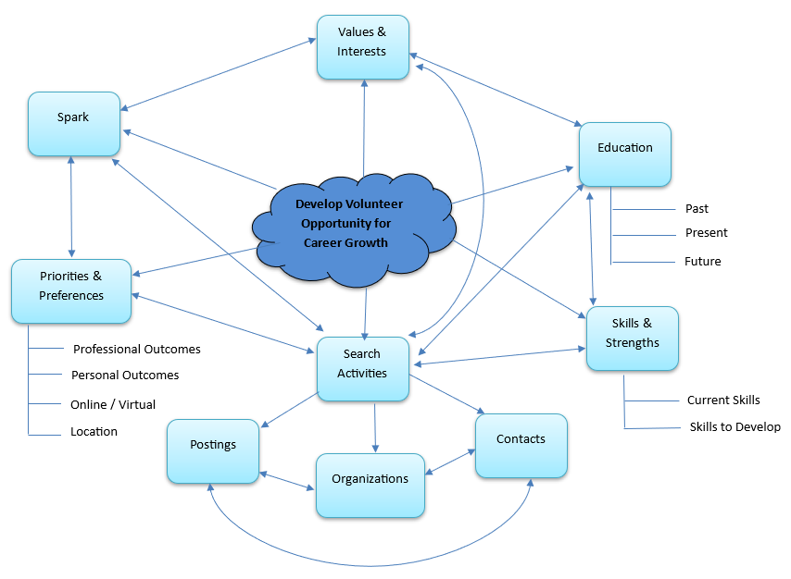

Key themes or terms:

Activity: Develop an Action Plan

Action | Tasks for To-Do List | Priority  (Low  Medium High) | Deadline or Timeline
Research / Identify  - Organizations  - Contacts  - Posting Sites  - Events | Use the Google Maps Search Nearby Tool and identify local potential organizations.
Prepare / Connect
- Search Tracking Spreadsheet
- Tailored Resume & Cover Letter
- Reach Out to Contacts
- View and Evaluate Postings
Apply / Network
- Set up Informational Meetings
- Register for Events
- Respond to postings

Track / Monitor
- New Contacts
- Important Organizations
- Potential Leads
- Application Follow-up

Leverage Your Success Back to Index

Activity: Document It
Choose elements of your volunteer experience and develop examples using the STARR format, which involves outlining the Situation, Tasks, Actions, and Results of each experience. Then, consider the Relevance of these examples to your personal growth. Do they align with your academic pursuits, research endeavors, skill enhancement goals, or aspirations in a specific role or industry?"

Once you have created examples from your experience, you can draw from this material to update your resume. As part of this update, ask your supervisor if they will be a reference for a future job search, or applications for academic programs, scholarships, or awards.

Example 1:
Situation(context)/Tasks:
Actions:
Results:
Relevance:

