

STRATEGIC VOLUNTEERISM: INSPIRING CHANGEMAKERS

exploratory search workbook

A Companion to Strategic Volunteerism: Inspiring Changemakers Moodle Course



march 2024

This **Exploratory Search Workbook** is provided to support your use of the Strategic Volunteerism: Inspiring Changemakers Moodle Course. You can print this out, or fill in digitally as you work through the different activities. Over time, this will emerge as your own personal portfolio of your Strategic Volunteerism journey and will also help you with your ongoing career management activities.

**Navigation tips:**

* To go to a page or a heading in this document without scrolling you can use the active links in the index below.

Or

* Use the built in Word Navigation pane. To open the Navigation pane, press Ctrl+F, or select the View tab and under the “Show” options, choose “Navigation Pane”.

# Workbook Index

🟠Find Your Spark

Activity: Reflective Question Exercise

🟡Assemble Your Skills

Activity: Uncover Your Personal Assets

Activity: RRU Personal Assets Inventory

Activity: Transferable Skills

Activity: Explore The Skills Landscape

🟣Develop Your Strategy

Activity: Set Your Priorities

Activity: Note Your Work Environment Preferences

Activity: Assess Your Timeline and Your Availability

🟢Plan Your Action

Activity: Put Together Your Assessment Information

Activity: Develop an Action Plan

Activity: Connecting With Community Mind Map

🔵Leverage Your Success

Activity: Document It

# Find Your Spark Back to Index

## Activity: Reflective Question Exercise

Finding your spark will require reflection, where you examine and consider your own ideas, thoughts, and feelings. This might be an unfamiliar or uncomfortable process, but you can strengthen your reflective abilities with practice.

You might not know where to begin so these reflective questions are a starting point for your self-analysis:

|  |  |
| --- | --- |
| **Question** | **Your Answer** |
| What causes do you care most about? |  |
| What have you done that feels easy for you and does not feel like work? |  |
| What skill or talent do you have that is fun for you? |  |
| What do you enjoy doing and want to continue doing? |  |
| Is there a course you are taking or research you are conducting that inspires you to learn more? |  |
| What do you not want to do? |  |
| Is there anything you would like to try doing, even if you could not be sure you would be good at it? |  |

Consider your responses above and look for any common ideas and themes in your answers.

|  |
| --- |
| **Common Ideas and Themes:** |
|  |

# Assemble Your Skills Back to Index

## Activity: Uncover Your Personal Assets

**Step 1: Compose Three Short Stories**

Capture three short stories or significant life experiences. Add a title or keyword that helps you remember each story.

|  |
| --- |
| **Story 1 Title:**  **Key Words:** |
|  |

|  |
| --- |
| **Story 2 Title:**  **Key Words:** |
|  |

|  |
| --- |
| **Story 3 Title:**  **Key Words:** |
|  |

**Step 2: Identify Skills, Values, and Strengths**

Identify the skills, values, and strengths that you demonstrated in each story into the allotted space in the table below. Start with story 1 and fill in each box. Refer to the instructions in the Moodle course for examples and a sample list of words that might help.

|  |  |  |  |
| --- | --- | --- | --- |
|  | **Story 1 Skills:** | **Story 1 Values:** | **Story 1 Strengths:** |
|  |  |  |  |

|  |  |  |  |
| --- | --- | --- | --- |
|  | **Story 2 Skills:** | **Story 2 Values:** | **Story 2 Strengths:** |
|  |  |  |  |

|  |  |  |  |
| --- | --- | --- | --- |
|  | **Story 3 Skills:** | **Story 3 Values:** | **Story 3 Strengths:** |
|  |  |  |  |

**Step 3: Discover Recurring Themes**

Identify and circle or highlight the skills, values, and strengths that recur in the stories. You can write them in the box below.

|  |
| --- |
| **Recurring themes:** |
|  |

## Activity: RRU Professional Assets Inventory

**Section 1: Uncover Your Core Assets**

**A. Interests:**

What activities, personal or professional, do you genuinely enjoy doing? What would you like to try out or learn more about?

|  |
| --- |
|  |

**B. Skills:**

List three accomplishments, big or small, that you felt good about in the past. You can use the three stories you identified for Uncover Your Personal Assets or provide new ones.

|  |
| --- |
|  |

What skills did you use to achieve these accomplishments? (e.g., Communication, Critical Thinking, Adaptability, Teamwork, Problem Solving)

|  |
| --- |
|  |

**C. Values:**

What are your core values? To answer this question, consider the following: What problems are you motivated to solve? What causes do you care most about? (e.g., Environmentalism, Family, Helping Others, Innovation, Prosperity, Efficiency)

|  |
| --- |
|  |

**D. Strengths:**

What are your natural talents? In what situations do you feel you are at your best or feel the best about your contribution?

|  |
| --- |
|  |

**Section 2: Discover Your External Assets**

**A. Professional Experience:**

What job roles have you previously fulfilled? Are there new roles you would like to explore?

|  |
| --- |
|  |

**B. Educational Experience:**

What educational experiences or certifications have you already acquired? What are you excited to learn more about next?

|  |
| --- |
|  |

**C. Support Network:**

Who are your mentors and biggest supporters? Who do you turn to for advice and support? Is there anyone you would like to reach out to?

|  |
| --- |
|  |

**D. Industry Knowledge:**

What additional resources, opportunities, and events are you interested in exploring to gather industry information that is related to your Spark? (e.g., conferences, professional associations, community groups, websites, social media, podcasts, news)

|  |
| --- |
|  |

**Section 3: Personal Assets Inventory**

Now that you have reflected on your Core Assets and your External Assets, review your answers in Sections 1 and 2, then copy each response to the corresponding unit of the Personal Assets Inventory in the table below:

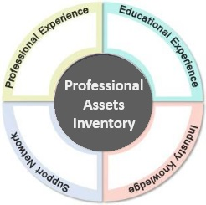

|  |  |
| --- | --- |
| **Interests** | **Skills** |
|  |  |
| **Values** | **Strengths** |
|  |  |
| **Professional Experience** | **Educational Experience** |
|  |  |
| **Support Network** | **Industry Knowledge** |
|  |  |

**Section 4: Ask for Feedback**

To get a broader perspective about your Professional Assets, reach out to your support network and ask for feedback. Ask various individuals the same questions.

**A.** What do you see as my natural strengths?

|  |
| --- |
|  |

**B.** What do you see as my greatest area for improvement?

|  |
| --- |
|  |

**C.** In what situations have you seen me struggle?

|  |
| --- |
|  |

**D.** In what situations have you seen me do my best work and contribute in a valuable way?

|  |
| --- |
|  |

**Section 5: Look for Patterns and Themes**

Review your information summary in Section 3 and your feedback in Section 4 and note any patterns or themes.

|  |
| --- |
|  |

## Activity: Transferable Skills

Examples provide evidence of skills because they demonstrate how a person has applied those skills in real-life situations. When someone provides examples of their past experiences, projects, or achievements, they display their abilities in action rather than simply stating that they possess certain skills. Examples offer concrete proof of capability, making them a powerful tool for showcasing skills.

**Develop Examples of Your Transferable Skills**

First, review this top 10 list of transferable skills:

|  |  |
| --- | --- |
| * Problem-solving | * Critical thinking |
| * Creativity | * Leadership |
| * Workforce digital skills (e.g., Microsoft Office) | * Resilience |
| * Communication | * Service orientation/customer service |
| * Collaboration | * Stress tolerance/dealing with stress |

Second, develop an example for each skill from your academic studies at Royal Roads using the STARS format for the next three prompts. You can refer to Moodle course for an example.

|  |
| --- |
| 1. Choose one transferable **skill that you enjoy using**: |
| **S**ituation(context)/Tasks: |
|  |
| **A**ctions: |
|  |
| **R**esults: |
|  |
| **S**kills demonstrated: |
|  |

|  |
| --- |
| 2. Choose one transferable **skill you would rate yourself as “better than average”**  **at using**: |
| **S**ituation(context)/Tasks: |
|  |
| **A**ctions: |
|  |
| **R**esults: |
|  |
| **S**kills demonstrated: |
|  |

|  |
| --- |
| 3. Choose one transferable **skill that you really have not become immersed in yet**: |
| **S**ituation(context)/Tasks: |
|  |
| **A**ctions: |
|  |
| **R**esults: |
|  |
| **S**kills demonstrated: |
|  |

## Activity: Explore The Skills Landscape

**Section 1: Labour Market Information (LMI)**

Find LMI information from at least three sources on the web that relate to your spark, an industry, a field or a job title that interests you. There are links on the course site to get you started, or you can find other sites of your choosing.

Note your answers to the following questions:

|  |
| --- |
| **How does the information you found align with your personal career interests, goals, and skills?** |
|  |

|  |
| --- |
| **How could you use these sites to your advantage for future use?** |
|  |

|  |
| --- |
| **Did you discover any surprising information?** |
|  |

**Section 2: Industries**

Use the web to investigate an industry of interest, an emerging industry, and a declining industry. You can choose from the industry list on the course site, or an industry of your choice. There are links on the course site to get you started, or you can find other sites of your choosing.

Note your answers to the following questions:

|  |
| --- |
| **What are some key industries that align with your interests or skills, and what aspects of each industry appeal to you?** |
|  |

|  |
| --- |
| **What challenges do these industries face?** |
|  |

|  |
| --- |
| **What information did you learn that could influence your search for a volunteer role?** |
|  |

**Section 3: Occupational Information**

Use the web to review an occupational profile of interest from two different sites. There are links on the course site to get you started, or you can find other sites of your choosing.

Note your answers to the following questions:

|  |
| --- |
| **What are the similarities between the profiles from each site?** |
|  |

|  |
| --- |
| **What are the differences between the profiles from each site?** |
|  |

# Develop Your Strategy Back to Index

## Activity: Set Your Priorities

What are important outcomes for your volunteer experience? The following table lists ideas but also take time to note any other significant priorities not listed.

|  |  |
| --- | --- |
| **Possible Outcomes** | **Your Choices** |
| Personal   * Contribute to activities or groups that impact communities * Make new friends and have fun * Stretch yourself to try something new * Increase your personal confidence |  |
| Professional   * Hone existing skills and build new skills to fill any competency gaps * Make professional connections and references * Explore a new job sector and gain relevant experience * Develop an understanding of your potential |  |
| Academic, project or research priorities? |  |
| Other significant priorities? |  |

## Activity: Note your Work Environment Preferences

It is important to review the work environment that works best for you. You might love working outside or you feel most comfortable working in an office setting. Take time to assess where you thrive.

|  |  |
| --- | --- |
| **Question** | **Your Preference** |
| Do you want to work in person your local area or are you open to virtual volunteering and working remotely? |  |
| Do you prefer indoor, outdoor, desk-based work? |  |
| Can you work with limited supervision, or do you like more direction from a supervisor? |  |
| Do you have other work environment preferences? |  |

## Activity: Assess Your Timeline and Your Availability

It is important to understand your timeline so can estimate the time you need for your search. You will also feel more confident committing to an opportunity when you know it is a good fit with your other school, work, and family commitments.

|  |  |
| --- | --- |
| **Question** | **Your Timeline / Availability** |
| Do you want an ongoing, short-term, or one-time commitment? |  |
| When do you want to start your volunteer experience? |  |
| Do you have an end date in mind? |  |
| How much time can you commit to your search? Can you set aside weekly time blocks? |  |
| For one-time commitments, are there date(s) that you are available? |  |
| For ongoing or short-term experiences, are there days/times when you are consistently available? |  |
| Any other timeline or availability considerations? |  |

# Plan Your Action Back to Index

## Activity: Put Together Your Assessment Information

Now that you have accumulated valuable details to inform your search, it is important to consolidate this information and look for connections. You can do this using a **table format** or you might find it useful to use a **concept map**. Both are described below.

Regardless of the approach you use to review your information, an important result is seeing the connections between the different self-assessment focus areas. For example:

* Connect specific class projects to related volunteer opportunities. For instance, if you are working on a project related to environmental sustainability, you could connect it to volunteer opportunities with local conservation organizations.
* Connect volunteer opportunities to specific skills or experiences that are relevant to your career goals. For example, if you are interested in pursuing a career in healthcare, you could connect volunteer work at a hospital to skills like patient care or medical knowledge.

**Approach One:** Create a summary table for your Spark, Skills, and Strategy assessments. Review the earlier pages in this workbook and fill out your information below. Consider all your information to identify key themes, words, or phrases that you can use for your search. Once your summary table is complete, use it as a tool to guide your actions and decision-making.

|  |  |  |
| --- | --- | --- |
| **Spark Common Themes:** | **Values:** | **Strengths:** |
|  |  |  |

|  |  |  |
| --- | --- | --- |
| **Skills You Enjoy:** | **Skills You Want to Develop:** | **LMI:** |
|  |  |  |

|  |  |  |
| --- | --- | --- |
| **Industries:** | **Occupational Information:** | **Work Environment Preferences:** |
|  |  |  |

|  |  |  |
| --- | --- | --- |
| **Personal or Professional Priorities:** | **Academic, Class Project or Research Priorities:** | **Timeline and Availability information:** |
|  |  |  |

|  |
| --- |
| **Key themes or terms:** |
|  |

**Approach Two:** Create a concept map for your Spark, Skills, and Strategy assessments. This can be an effective way to visually organize your thoughts, ideas, or information and identify important connections. Once your concept map is complete, use it as a tool to guide your actions and decision-making.

Start with your main objective at the center of the concept map. Create branches radiating out from the center representing the main categories or areas of focus related to your objective. Expand each main branch with sub-branches representing related information, specific tasks, or actions within each category. The diagram below is an example of how you might do this.

Consider all your information to identify key themes, words, or phrases that you can use for your search.

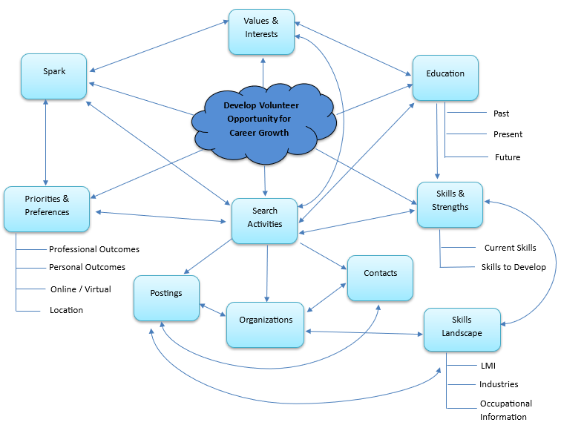

|  |
| --- |
| **Key themes or terms:** |
|  |

## Activity: Develop an Action Plan

|  |  |  |  |
| --- | --- | --- | --- |
| **Action** | **Tasks for To-Do List** | **Priority**  **(Low**  **Medium High)** | **Deadline or Timeline** |
| Research / Identify   * Organizations * Contacts * Posting Sites * Events | Use the Google Maps Search Nearby Tool and identify local potential organizations. | High | Within 7 days |
| Prepare / Connect   * Search Tracking Spreadsheet * Tailored Resume & Cover Letter * Reach Out to Contacts * View and Evaluate Postings |  |  |  |
| Apply / Network   * Set up Informational Meetings * Register for Events * Respond to postings |  |  |  |
| Track / Monitor   * New Contacts * Important Organizations * Potential Leads * Application Follow-up |  |  |  |

## Activity: Connecting With Community Mind Map

Use the table provided (the equivalent of the visual mind map) to record the names of people you know in the different suggested categories, i.e., immediate circles, professional associations, or committees. Fill in the boxes with their names, as other people come to mind, add their names too.

Next you can add people who you do not know directly such as influencers in your field, or someone you met at a conference who is doing work that interests you. You can also explore alumni networks, industry-related organizations, and social media connections for further networking opportunities. These are secondary connections: people in your primary group may know and could offer an introduction.

Here are further ideas: parent-teacher groups, faith-based or spirituality circles, your professors, mentors, clubs like Royal Roads Proud or the Diversity Action Group, classmates, and former employers.

|  |  |
| --- | --- |
| **Category** | **Connections** |
| Existing Community |  |
| Service Committees |  |
| Professional Associations |  |
| Alumni |  |
| Organizations You Are Interested In |  |
| Linked In |  |
| Conferences |  |
| Other |  |

# Leverage Your Success Back to Index

## Activity: Document It

Choose elements of your volunteer experience and develop examples using the STARR format, which involves outlining the Situation, Tasks, Actions, and Results of each experience. Then, consider the Relevance of these examples to your personal growth. Do they align with your academic pursuits, research endeavors, skill enhancement goals, or aspirations in a specific role or industry?"

Once you have created examples from your experience, you can draw from this material to update your resume. As part of this update, ask your supervisor if they will be a reference for a future job search, or applications for academic programs, scholarships, or awards.

|  |
| --- |
| **Example 1:** |
| **S**ituation(context)/Tasks: |
|  |
| **A**ctions: |
|  |
| **R**esults: |
|  |
| **R**elevance: |
|  |

## Explore Your Teamwork Competencies & Skills

Engaging your volunteer experience may have provided you with valuable opportunities to put these teamwork skills into practice. Use the Royal Roads Teamwork Competencies and Skills framework to reflect on your experience to identify and evaluate the specific teamwork elements you developed or demonstrated. Use can you the STARR format to develop examples.

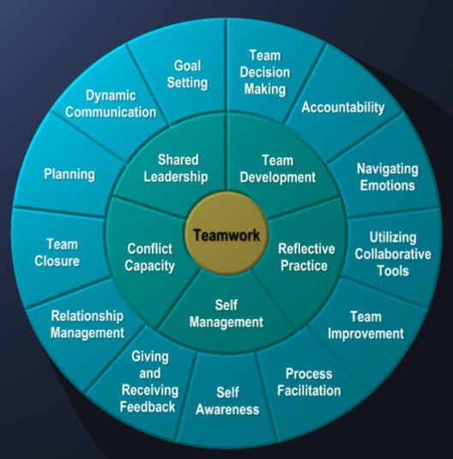

|  |
| --- |
| **Skill:** |
| **S**ituation(context)/Tasks: |
|  |
| **A**ctions: |
|  |
| **R**esults: |
|  |
| **R**elevance: |
|  |